1000 S. Odell Street, Brownsburg, IN 46112 ● (317) 520-1372 ● Team3176@brownsburg.k12.in.us
Team 3176 Purple Precision is a robotics team located in Brownsburg, Indiana. We are funded almost entirely by independent sponsorships and donations. As part of an organization called FIRST, we participate in annual competitions and work to promote science, technology, engineering, and math (STEM). Over the years, our team has continued to grow and improve, and we have made many accomplishments, such as winning the 2016 Indiana State Championship and being a consistent Semi-Finalist. We appreciate your consideration!
 | In Kind | Bronze $100-$499 | Silver $500-$999 | Gold $1000-3499 | Purple $3500+
Representation on website | ✔ | ✔ | ✔ | ✔ | ✔
Small font name and logo display in Pit | ✔ | ✔
Medium font name and logo display in Pit |  |  | ✔
Large font name and logo display in Pit |  |  |  | ✔ | ✔
Name on competition robot |  |  | ✔ | ✔ | ✔
Medium logo on competition robot |  |  |  | ✔
Large logo on competition robot |  |  |  |  | ✔
Company highlighted in quarterly newsletter |  |  | ✔ | ✔ | ✔
Verbal representation at team-led and community events |  |  |  |  | ✔

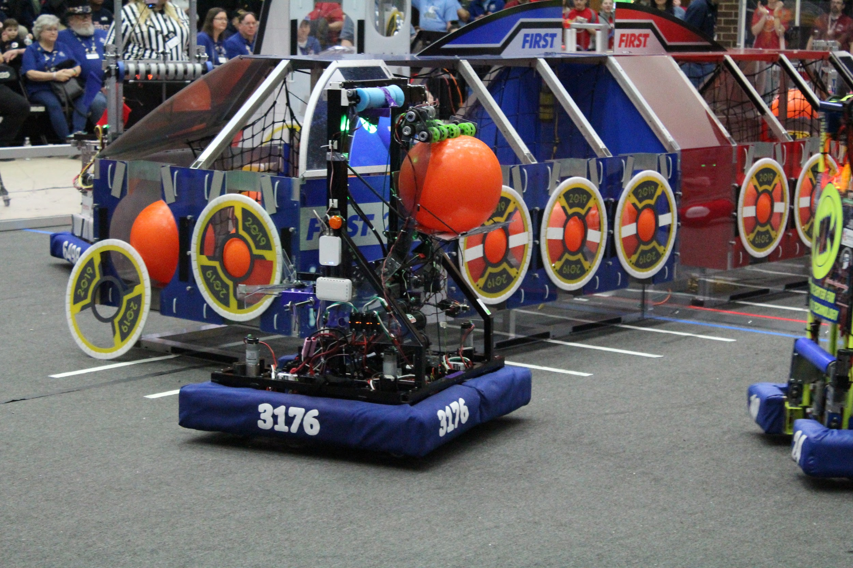
Team 3176 is 501(c)(3) organization. Your donation is fully tax deductible. Checks made payable to BCSC with Team 3176 in memo line. If you have any questions please contact us using the information provided above or visit Team3176.com!

